Creating a Scrum Project with Backlog and Sprint in Jira

Aim
To create a Scrum project in Jira, add tasks to the product backlog, create a sprint, and track project progress using Agile Scrum methodology.

Procedure
- Open Jira in the browser and log in using your account.
- Click Projects/Spaces and create a new software project.
- Select the Scrum template.
- Enter the project name as My Software Team and create the project.
- Open the Backlog section from the project menu.
- Create the following tasks:
  - Student Registration
  - Student Login
  - Search Books
  - Issue and Return Books
- Create a new sprint named Sprint 1.
- Move all four tasks from the backlog into Sprint 1.
- Set the sprint duration to two weeks and enter the sprint goal as Complete basic library management functions.
- Click Start Sprint to begin the sprint.
- Open the Board section to view the active sprint.
- Track task progress by moving tasks between the following columns:
  - To Do
  - In Progress
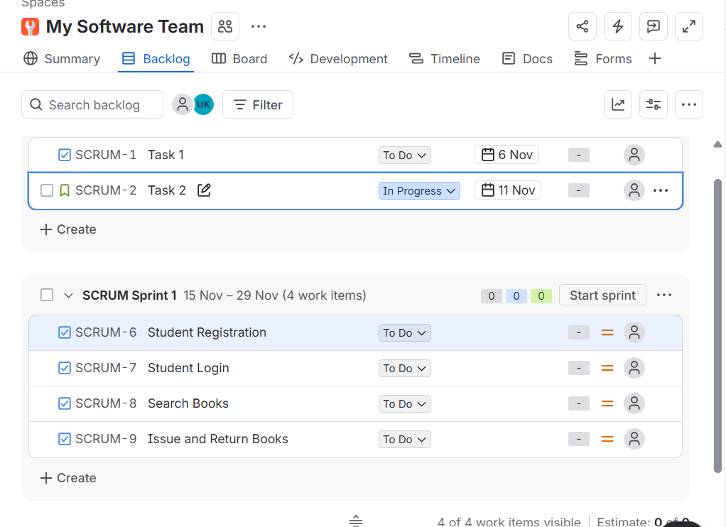
  - Done

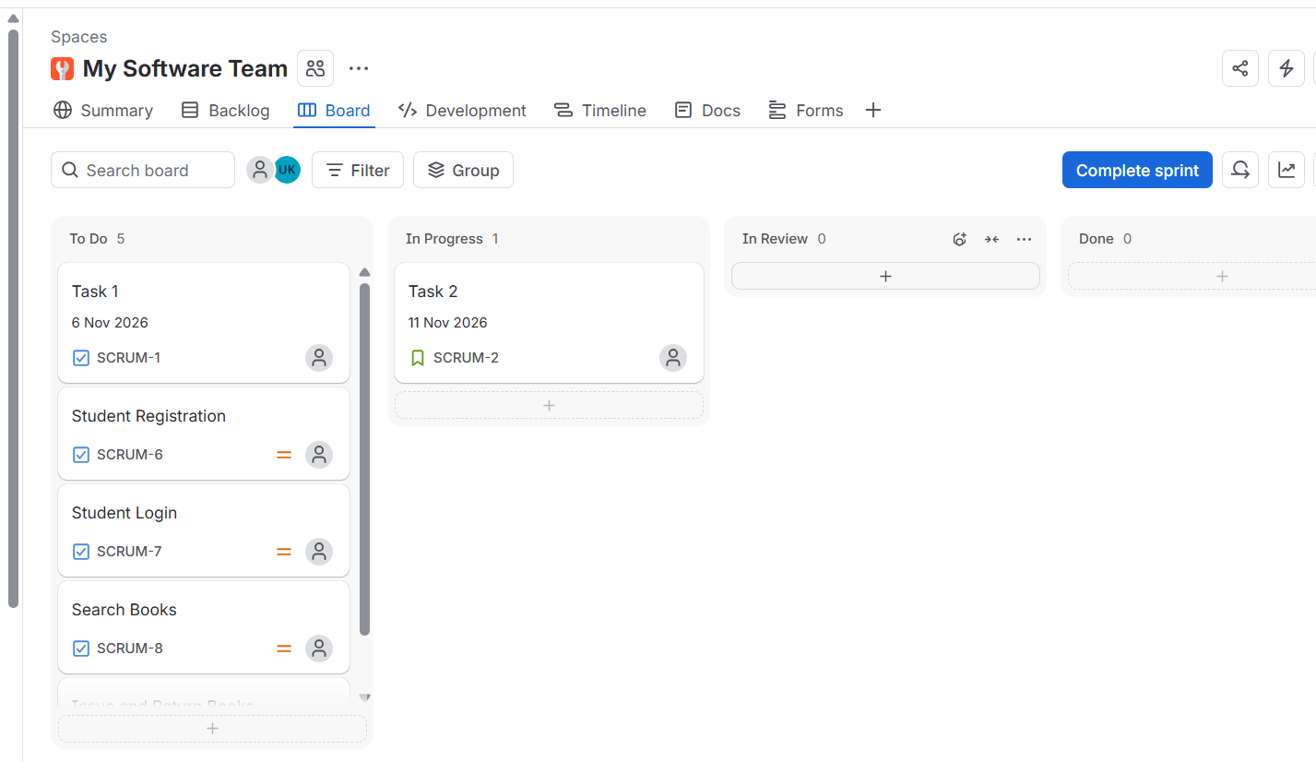

Result
Successfully created a Scrum project named My Software Team in Jira. Added tasks to the product backlog, created and started Sprint 1, and tracked task progress using the Scrum board.


